**VibeShop Project Description**

**Bianca Cristina Badeu 315270**

**Dominika Ignatowicz 315277**

**Luis Daniel Guzman 315194**

**Maria-Elisabeta Mihai 315231**

**Supervisors**

**Jakob Knop Rasmussen**

**Joseph Chukwudi Okika**

**Software Technology Engineering**

**3rd Semester**

**09/08/2022**

**Table of content**

1. Background Description 1

2. Problem Statement 3

3. Definition of purpose 4

4. Delimitation 5

5. Methodology 6

6. Time schedule 7

7. Risk assessment 8

8. Sources of Information 9

Appendices (including Group Contract)

# Background Description

Everyday life has developed in different ways throughout the years, things that once used to be necessary such as going to the stores and buying items have become digitalised. Nowadays, it is easier than ever to obtain any kind of item thanks to the internet. As mentioned by Bill Gates “The Internet is becoming the town square for the global village of tomorrow”.

E-commerce is the word which defines these digital activities, as explained by Oxford Dictionary, it is any business that is conducted on the internet. Perhaps one of the greatest examples of this word is Amazon, a massive corporation which currently dominates the e-commerce market with over 200 million customers every month accessing their website.

However, it is common in these companies and corporations to see this trending business model and not change or improve aspects due to fear of them creating an opposite reaction or not being successful.

One of the most remarkable issues within these corporations is that they do not take into consideration the impact that is provoked in the environment by their actions and do not engage in social responsibility.

Nowadays these concepts are essential in the market. Therefore, the UN has established 17 goals for sustainable development which governments, businesses and people should engage upon. Therefore, there is a level of responsibility to complete these goals by companies.

This is especially true with the “Responsible consumption and production” sustainable goal, which establishes that the practices within corporations, companies and individuals that are engaging in the harvesting, transport, storage, and processing of products must not contribute to pollution, biodiversity loss or contribute to climate change.

Therefore, people who are buying from companies that disregard the sustainable goal mentioned above, are indirectly contributing to further deteriorating the state of the world. That is why, humanity needs to be aware of their own implications on the environment and try to resort to more sustainable items and the companies that produces them.

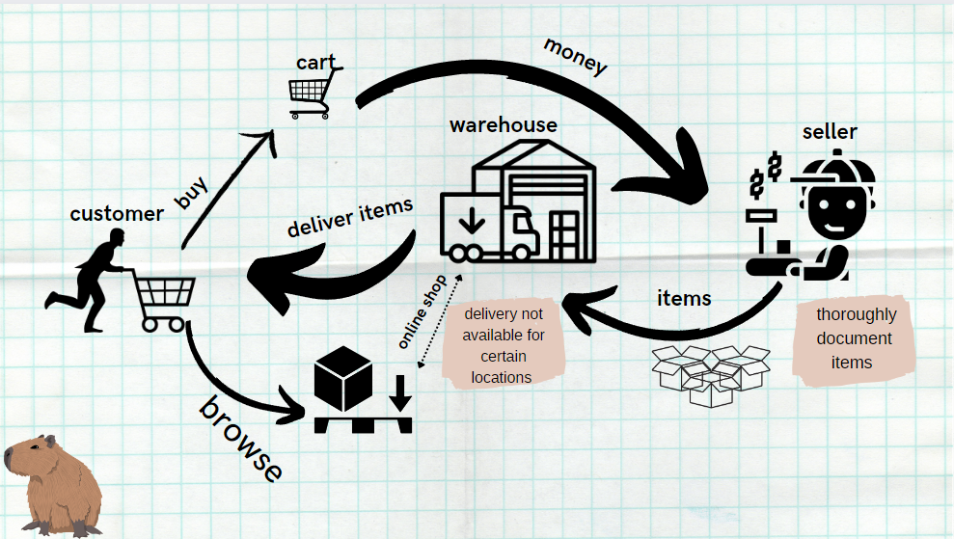

# Problem Statement

**Main problem**

Responsible consumption and production practices are not present in most businesses nowadays, leaving customers misinformed.

- What is the process behind sustainable production practices?

- What misinformation are businesses spreading about their products?

- Why should sustainability be important for the customers?

- Which advantages would the sustainable items and practices have in the everyday life?

- What are the companies doing now that is considered sustainable?

# Definition of purpose

The purpose is to provide sustainable products that customers can access from anywhere, alongside bringing awareness about sustainable practices.

# Delimitation

* The amount of product variety will be limited to 4 categories with 15 items per category; each item having different variations.

# Methodology

Unified Process is based on the enlargement and refinement of a system through multiple iterations, with cyclic feedback and adaptation. The system is developed incrementally over time, iteration by iteration. This method will be used along with its phases in this SEP3 project.

SCRUMBAN will be used as the framework. This consist of the general idea of SCRUM with extra elements taken from Kanban.

SCRUM:

* Roles (Scrum Master - Dominika, Product Owner - Elisabeta, Team Members – Bianca and Luis)
* Meetings (Daily meetings, Review meetings – every Wednesday, Retrospective meetings – every Wednesday, Sprint planning meeting – every Wednesday)

KANBAN:

* Kanban board (a visual representation of tasks)
* Continuous work (on Wednesday, the tasks that are not completely done will remain “in progress” instead of returning to “not started”)
* Priority of tasks (depends on the relevance of the task)

# Time schedule

The expected time for this project from all members is 275 hours per member. The group expects the project to be completed by December 15th.

* 1st milestone – Project Description
* 2nd milestone – Architecture
* 3rd milestone – Proof of Concept
* 4th milestone – Finalizing project
* 5th milestone – Deadline

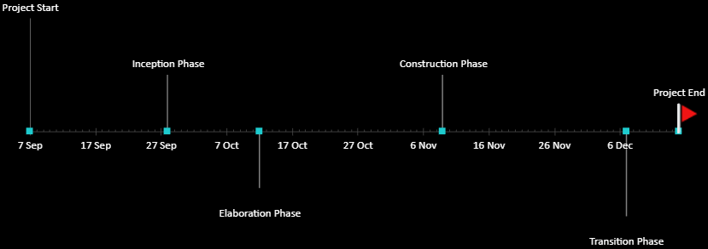

# Risk assessment

|  |  |  |  |  |  |  |
| --- | --- | --- | --- | --- | --- | --- |
| Risks | Likelihood  Scale: 1-5  5 = high risk | Severity  Scale: 1-5  5 = high risk | Product of likelihood and severity | Risk mitigation e.g., Preventive- & Responsive actions | Identifiers | Responsible |
| Keeping on track | 4 | 5 | 20 | Set up realistic and clear objectives. | Time consuming tasks that prevent effective results | Luis |
| Handling compatibility issues between different programming languages | 5 | 4 | 20 | Researching about the transfer protocols | Importing and exporting objects having errors/issues | Maria-Elisabeta Mihai |

# Sources of Information

Burtle, L., Head, S., Lankford, S., Nielsen, K., Wood, J. and White, D., 2002. A Brief History of the Internet. [online] Usg.edu. Available at: <https://www.usg.edu/galileo/skills/unit07/internet07_02.phtml> [Accessed 23 March 2022].

Gates, B., 2013. Bill Gate on the internet. Interview conducted August 8th. [Accessed 13 September 2022]

Quaker, D., 2022. Amazon Stats: Growth, Sales, And More - Tips, Info, And Stories About Selling In Amazon Stores. Whether You're Just Getting Started Selling Online Or Building An Ecommerce Empire, The Amazon Selling Partner Blog Features Articles To Help You Get There.. [online] Amazon Selling Partner Blog. Available at: <https://sell.amazon.com/blog/grow-your-business/amazon-stats-growth-and-sales> [Accessed 21 September 2022].

Calma, J., 2022. Amazon's Climate Pollution Is Getting Way Worse. [online] The Verge. Available at: <https://www.theverge.com/2022/8/1/23287351/amazon-climate-change-carbon-emissions-worse-2021> [Accessed 21 September 2022].

**Appendices**

* Group Contract